Invitation

to the World’s greatest & most skilful sport
& somehow Ireland’s best kept secret

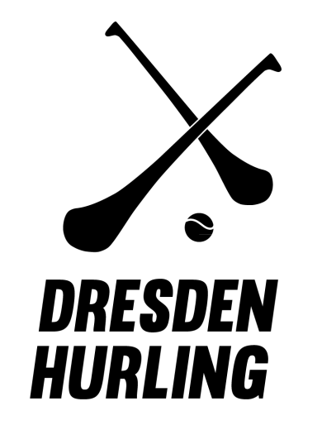
&
Gaelic Games Europe

presents

The GAA
European Hurling & Camogie
Championship Finals

Saturday 15. October 2016
09:00 - 18:00

Sportpark Ostragehege
Google maps “Dresden Hurling”
------
3 course dinner at “Wenzels Prager Bierstuben” - 19:30-21:30
Party with us at “Club Standesamt” - from 22:00

Sponsored by

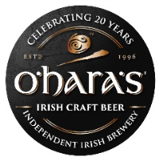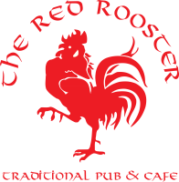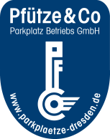

Welcome
On behave of all here in Dresden Hurling, it’s a privilege to welcome and play host to you all, the Hurlers and Camogs of continental Europe. We hope this booklet will help you to plan your trip and make it easier to relax and enjoy your weekend here in the so called “The Florence on the Elbe”. Should you have any questions regarding any aspect of the weekend please don’t hesitate to contact us.

Please circulate this among those travelling. But just a note: so you don’t have to go looking through emails, all the necessary content of this booklet is available on our website www.dresdenhurling.de

Clubs and players attending:

Belgium, Luxembourg, Den Haag, Eindhoven, Amsterdam, Zurich, Basel, Vienna, Dublin, Berlin, Hamburg, Munich, Cologne, Darmstadt, Stuttgart and Dresden.

Invited guests:

We are honoured and privileged that the following guests will join us for the weekend for what will be a momentous day for the Hurling club.

- Mr Michael Collins The Irish Ambassador to Germany
- Ms Catherine Neary The President of the Camogie Association
- Ms Joan O'Flynn The CEO of the Camogie Association
- Mr Aogán Ó Fearghaíl The President of the Gaelic Athletic Association
- Dr. Peter Lames The Dresden Bürgermeister

The tournament will be filmed by Jerome Quinn Media who will travel from Ireland to capture the events of the weekend. Snippets will be available to watch online throughout the day and official video will be available from the following Tuesday.

Important addresses & contact details

Tournament: (Type Dresden Hurling into Google maps to find pitch location) See map below for free parking
Sportpark Ostragehege,
Magdeburger Strasse 10
01067 Dresden
Tram stop: Kongresszentrum, Line 6 or 11 (6 minute walk)
​
The Dinner:
Wenzels Prager Bierstuben
Königstraße 1,
01097 Dresden
Tram stop: Palaisplatz, Line 4 or 9 (1 minute walk)
Albertplatz, Line 3, 6, 7, 8, 11 (4 minute walk)

The Party:
Club Standesamt
Palaisplatz 2,
01097 Dresden
Tram stop: Palaisplatz, Line 4 or 9 (1 minute walk)
Albertplatz, Line 3, 6, 7, 8, 11 (4 minute walk)

The Sponsors Bar:
The Red Rooster Bar: (Friday night greeting)
Rähnitzgasse 10,
01097 Dresden

Friday evening:

We will greet the teams and guests on Friday evening at 20:00 at our sponsors bar, The Red Rooster on Rähnitzgasse 10 and at 21:00 we will take all present on a one hour walking tour of Dresden Altstadt.
For a quick 3 minute bird’s eye video of Dresden click here.

Saturday: Tournament

The tournament fees will be as follows
€10 Registration
€5 Lunch (optional)
€20 Dinner (optional)

As we will have a lot of teams competing, the matches will start at 9:00 sharp. The registration tent will be open from 8.30 and will close at 10.30. Please have team sheets and disclaimer forms printed and signed.
Clubs are asked to pay their fees (see below details) to our club bank account before Monday 10th October.

There are three playing fields. Two of them are grass which will be used by the hurlers and the other is AstroTurf to be used by the camogs. We hope to arrange that the Camogie semi-finals and final will be played on a grass field. Please bring appropriate playing boots for both surfaces.

Bearing in mind the amount of teams competing and the time of year with sunset due at 18.10 we will be keeping you informed as to when you will be expected on the field. There will be a 5 minute turn around between games, so please take the field directly after the final whistle of the previous game. Tim the MC will let you know by microphone and loud speakers.

Lunches will be available from 11.30 from the registration tent. You can expect some Irish food, Irish drink and Irish music and of course Irish sport throughout the day. There will also be some Cultec Hurleys available to purchase at the bar.

From 14:00-16:00, there will be a “Crossbar Challenge” to raise awareness of depression and suicide among young people. Players and spectators are asked to donate €2/shot. Your target is of course the crossbar and should you hit it with the sliotar from a specified distance, you will receive a drink and a portion of food from the bar. When teams are in between games, players can partake in their own time.

There will be tents provided in case we are blessed with some Irish weather.

Depending on light it is planned to present the winning cups on the field after the final game.

Saturday: Come in for the dinner

Afterwards, from 19:30-21.30, the players and dignitaries will dine at the restaurant “Wenzels Prager Bierstube” on Königstraße 1 in the Neustadt. It is a 15 minute walk from the pitches. There will be a 3 course sit-down dinner with two starters, three main courses and two deserts to choose from. It will be a hearty bohemian menu. Please provide us with necessary dietary requirements for your players.

Saturday: Party!

From around 21.45, short speeches, winning medals and player of the tournament awards will be presented in Club Standesamt. We have booked the entire building for the night. The club is around the corner from the restaurant so after your meal you can make your way there. Over two floors there is a bar, lounge and dance floor. It will stay open until 05:00. Entrance is free for players and guests. At registration on Saturday morning you will receive tickets for each player. Entrance at the door will cost €3 without a ticket and is open to the public.

Transport:

Flights Direct from Zurich, Basel, Amsterdam, Munich, Stuttgart, Hamburg.
Dresden Airport destination map
Berlin and Prague is a 2 hour drive.
Bus www.busliniensuche.de (7-15euro from Berlin to Dresden)
Car rental Economy car rentals Argus Car Hire (~40-50 euro Friday to Sunday)
Train www.diebahn.de
Car share www.blablacar.de

We have always travelled using our own cars to Brussels (778km – 8 hours) Den Haag (772km), Zurich (720km), Luxembourg (685km) Copenhagen (627km), and found this to be the easiest, sometimes fastest (door to door) and cheapest mode of transport working out at about 40-50 euro total per person.

Transport in Dresden:

Free parking
Park up your car for the weekend at our sponsors parking lot in the middle of the city (3 mins walk from the post-tournament restaurant and party) and use public transport. Contact us to arrange tickets.

There is plenty of free parking at the tournament Sportspark. (see graphic below)

Travel throughout Dresden is easy with a well-integrated bus and tram network. One way tickets are €2.20 and are valid for 1.5 hours after stamping the ticket. 4 way ticket cost €8.20. Tickets can be bought in the trams using coins only or on the platform machines using cards and notes. €40 fine if you’re caught without a valid ticket.

See: https://www.dvb.de/en-gb/ to plan your route from A to B

Accommodation:

Hotels: (*recommended for price, cleanliness and location)
Ibis budget hotel *
Ibis hotels (3)
Holiday inn
Motel one *
Hotel B&B *
NH Altstadt
Park inn by Radisson *

Hostels:
http://www.mezcalero.de/en/
http://www.louise20.de/
http://www.lollishome.de/en/
http://www.mondpalast.de/www/content.php?&lang=en&abt=home
http://www.kangaroo-stop.de/en_preise.phtml
http://www.lalelu-hostel.de/en/category/hostel-2
http://www.studenthouse.de/en/index.php

The AirBnB website has some apartments available for 5-9 people in Dresden.

Things to do in Dresden:

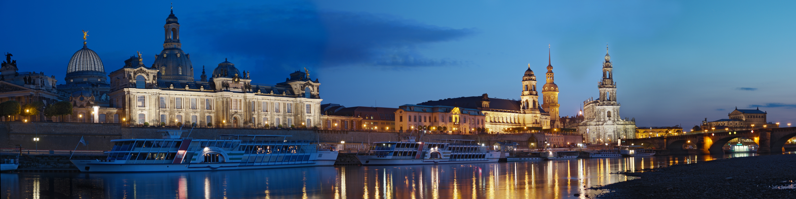

After you have travelled all the way to Dresden why not take some additional time to explore this beautiful city. From the magnificent buildings of the Altstadt, such as the Frauenkirche and Zwinger palace, to the nightlife of the Neustadt, or the beer gardens along the river Elbe, there is something for everyone.

For further information see:
http://www.lonelyplanet.com/germany/saxony/dresden

For a quick 3 minute bird’s eye video of Dresden click here.

Contact persons:

Diarmuid Kelly  Chairperson | Jaakko Harjuleto /  Ivan O‘Connor  Secretaries | Julia Kohl  Treasurer | Tim Crowley  PRO
Chairperson.Dresden.Europe@gaa.ie  0049 1522 864 7727 | Secretary.Dresden.Europe@gaa.ie | Treasurer.Dresden.Europe@gaa.ie | PRO.Dresden.Europe@gaa.ie

Sports Park map:

Pitches in bright green
Changing rooms entrance dark blue arrow
Free Parking in light blue
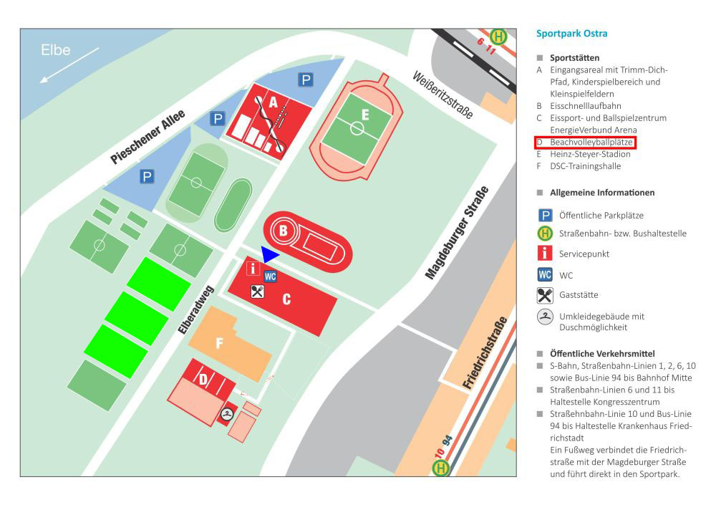

More tournament and team information on our website
www.DresdenHurling.de

